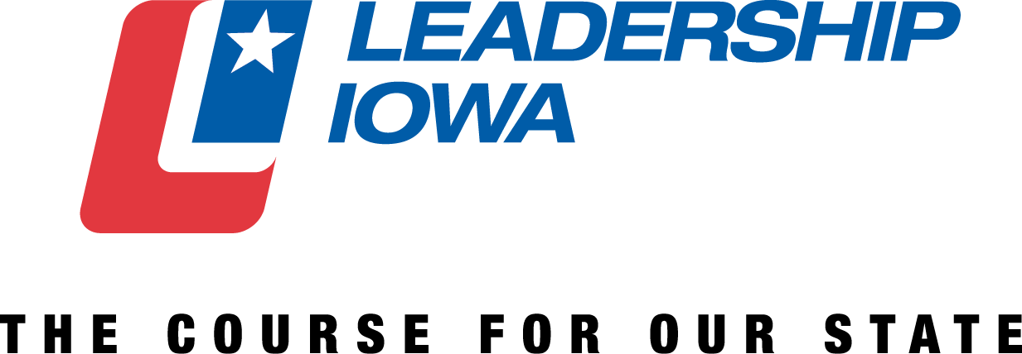

The Leadership Iowa Board of Governors invites you to nominate candidates for this year’s Leadership for Iowa Award. Nominations are due by Monday, April 15. This award is presented annually to an alumnus of the Leadership Iowa program and is based on the following criteria.

Leadership for Iowa Award nominees must:

- Show a demonstrated commitment to serve Iowa
- Have a responsible position of leadership in employment and/or volunteer organizations, resulting in the potential to contribute to leadership development within a local or a statewide setting

- Have demonstrated a leadership role in local or statewide volunteer service to civic or professional organizations
- Have demonstrated the ability to undertake a leadership role on difficult or controversial subjects
- Be involved in projects designed to enhance the quality of life in Iowa
- Ideally be present for the presentation of the award (ABI Taking Care of Business Conference – June 6 in Ames, IA)

NOMINATION FORM

NAME OF NOMINEE:
LI CLASS:
ADDRESS:
CITY, STATE, ZIP:
HOME PHONE: WORK PHONE:
E-MAIL ADDRESS:
NOMINATOR NAME:
NOMINATOR PHONE: NOMINATOR EMAIL:
Please use a separate page for your answers to these questions if you wish.
- Describe how this candidate shows a demonstrated commitment to serve Iowa.

- Does the candidate have a responsible position of leadership in employment and/or volunteer organizations that results in the potential to contribute to leadership development within a local or a statewide setting? If so, please describe.

- Describe how the candidate has demonstrated a leadership role in local or statewide volunteer service to civic or professional organizations.

- Describe how the candidate has demonstrated his/her ability to undertake a leadership role on difficult or controversial subjects.

- Describe what projects the candidate has been involved in that have enhanced the quality of life in Iowa.

RETURN TO: Jessi Steward - ABI Foundation | 400 East Court Ave., Suite 100 | Des Moines, IA 50309 | jsteward@iowaabi.org
DEADLINE: APRIL 15, 2019

